**HO CHI MINH UNIVERSITY OF TECHNOLOGY AND EDUCTION**

Faculty for High Quality Training

Information Technology

****-----🙞🙜🕮🙞🙜-----

**FINAL PROJECT REPORT**

PROJECT: Building online table reservation website

Subject: Database Management System

Lecturer: Ths. Nguyễn Thành Sơn

**Group 04**

**Members**:

Trương Minh Hoàng 18110016

Lê Quang Huy 18110018

Hoàng Minh Khang 18110021

Ngô Minh Thành 18110045

Nguyễn Thị Cẩm Tú 18110063

Lê Viết Long 19110087

*Thành phố Hồ Chí Minh, ngày 21 tháng 5 năm 2021.*

Contents

PREAMBLE 3

CHAPTER 1: PROGRAM OVERVIEW 4

CHAPTER 2: DATABASE DESIGN 5

I. Relational model 5

a. Current status analysis 5

b. Current business status report 5

DATABASE DESCRIPTION 7

1. Database Diagram: 7

2. Tables: 7

3. Functional components 10

*a.* *Stored-procedure* 10

b. Triggers 11

c. Functions 12

CHAPTER 3: PROGRAM VISUALIZATION 13

1. Sign in/sign up 13

2. User interface 15

a. Main interface 15

b. Restaurant list 15

c. Add to list favorite 16

d. Information helpful 17

e. Booking table 18

f. Review 19

3. Manager interface 20

a. Admin page 21

b. List restaurant 21

c. List user 22

# PREAMBLE

Thank us lecturer-Ths Nguyễn Thành Sơn for amazing lectures and discussions! We really enjoyed this class, was actually excited to come to class every lesson, learned a lot and benefited from your course. Thanks for facilitating such a positive learning environment.

Thank you so much for caring about both what you’re teaching and how you teach it for this semester. For your patience and for creating an environment where we aren’t only allowed to succeed but also to fail. For caring for the students and training us. For allowing us to question without judging and for having growth mindset with us. Students succeed when students feel the freedom to image and trust you give. You are a very good lecturer. You continue to impress us more and more with your knowledge, creativity and engaging coursework.

# CHAPTER 1: PROGRAM OVERVIEW

**Interface specification:**

**Login page:** used to decentralize access to the website to book the service.

**Home page:** includes a menu bar that displays a list of services and dishes that the restaurant offers, provides additional functions: search bar, classify, compare, and provide users with the operation. simple and handy items as well as information about the website and its service, ...

**Restaurant list page:** Displays a list of restaurants and restaurant details. Managers can perform functions such as adding, deleting and editing restaurant information.

**Statistics page (only for admin)**: shows information including transaction information that customers book for each restaurant, statistics chart showing restaurant's sales.

**User list page:** Displays a list of users and detailed information about the user. Managers can perform functions such as adding users, deleting users, and editing users.

**Account information page:** provides users to view personal information such as full name, date of birth, phone number, email, profile picture, change information as well as change password.

# CHAPTER 2: DATABASE DESIGN

## Relational model

### Current status analysis

Nowadays, with busy life, most people tend to find eateries out. Therefore, with the technology age, the number of tables available online is increasing. Therefore, a network reservation management application is essential. This app makes it easy for users to search for eateries by their time and location, and even compare prices. This leads to saving time and money. From the above interests we decided to build this web application, with the following characteristics:

• Highly user-friendly

• Cross-platform

• Easy-to-use

• Tested system to track unnoticed error

• Data entry restricted to valid domains (to avoid errors)

### Current business status report

* 1. **Website interface**

**Link:** https://www.now.vn/ho-chi-minh/table

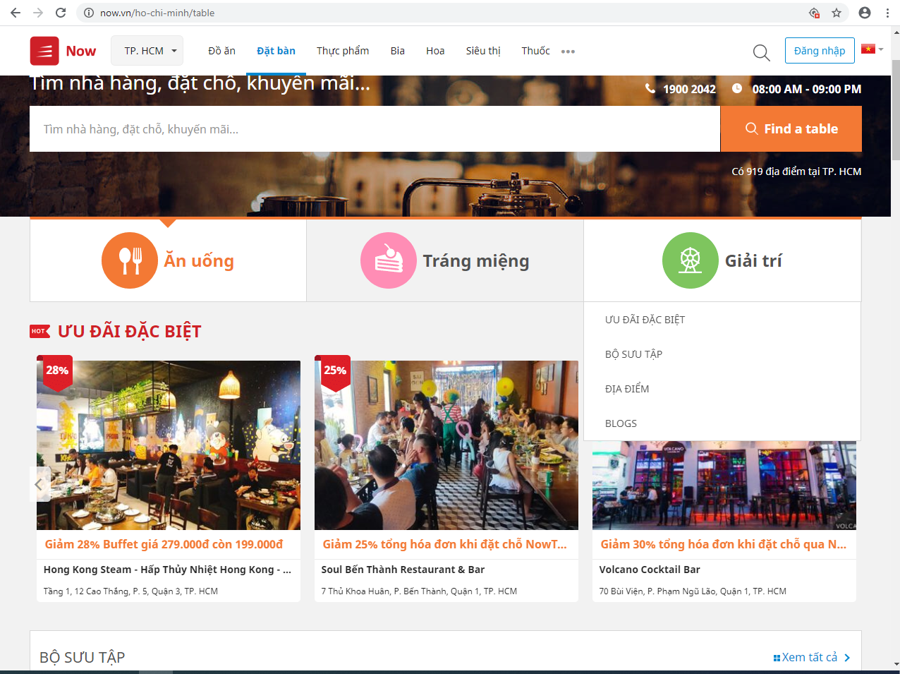

**Advantages:**

* Mordern interface
* User friendly
* Provide enough necessary function

**Disadvantages:**

* Internet connection requirement

# DATABASE DESCRIPTION

## Database Diagram:

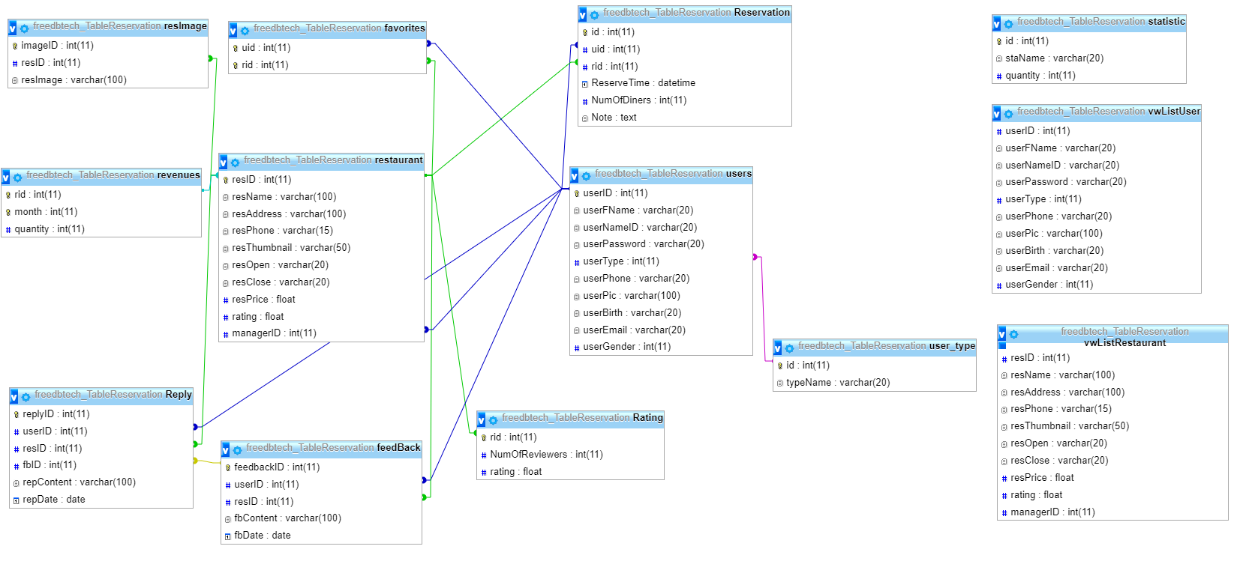

## **Tables**:

|  |  |  |  |  |  |
| --- | --- | --- | --- | --- | --- |
| **ID** | **Attribute** | **Type** | **Range** | **Meaning** | **Notes** |
| 1 | resID | Int | PRIMARY KEY | Restaurant id |  |
| 2 | resName | Varchar(20) |  | Restaurant name |  |
| 3 | resEmail | Varchar(20) |  | Restaurant email |  |
| 4 | resPhone | Varchar(20) |  | Restaurant phone |  |
| 5 | resAddress | Varchar(20) |  | Restaurant address |  |
| 6 | resImg | Varchar(100) |  | Restaurant image |  |
| 7 | resOpen | DateTime |  | Restaurant open time |  |
| 8 | resClose | DateTime |  | Restaurant close time |  |
| 9 | resMenu | Varchar(100) |  | Restaurant menu |  |
| 10 | resRating | Int |  | Restaurant rating |  |
| 11 | resDesc | Varchar(100) |  | Restaurant  Description |  |
| 12 | managerID | Int | FOREIGN KEY | Restaurant manager id |  |

Table 2.1: Restaurant

|  |  |  |  |  |  |
| --- | --- | --- | --- | --- | --- |
| **ID** | **Attribute** | **Type** | **Range** | **Meaning** | **Notes** |
| 1 | resrID | Int | PRIMARY KEY | Reservation id |  |
| 2 | userID | Int | FOREIGN KEY | User id |  |
| 4 | resrDate | DateTime |  | Reservation date |  |

Table 2.2: Reservation

|  |  |  |  |  |  |
| --- | --- | --- | --- | --- | --- |
| **ID** | **Attribute** | **Type** | **Range** | **Meaning** | **Notes** |
| 1 | userID | Int | PRIMARY KEY | User id |  |
| 2 | userName | Varchar |  | User name |  |
| 3 | userPhone | Varchar |  | User phone |  |
| 4 | userEmail | Varchar |  | User email |  |
| 5 | userImage | Varchar |  | User image |  |
| 6 | userNameID | Varchar |  | User name for login |  |
| 7 | userPassword | Varchar |  | User password |  |
| 8 | userType | Int | FOREIGN KEY | User type |  |
| 9 | userAddress | Varchar |  |  |  |

Table 2.3: Users

|  |  |  |  |  |  |
| --- | --- | --- | --- | --- | --- |
| **ID** | **Attribute** | **Type** | **Range** | **Meaning** | **Notes** |
| 1 | id | Int | PRIMMARY KEY | **Type id** |  |
| 2 | typeName | Int |  | User id |  |

Table 2.4: Users

|  |  |  |  |  |  |
| --- | --- | --- | --- | --- | --- |
| **ID** | **Attribute** | **Type** | **Range** | **Meaning** | **Notes** |
| 1 | fbID | Int | PRIMARY KEY | Feedback id |  |
| 2 | userID | Int | FOREIGN KEY | User id |  |
| 3 | resID | Int | FOREIGN KEY | Restaurant id |  |
| 4 | userName | Varchar |  | User name |  |
| 5 | userComment | Varchar |  | User comment content |  |

Table 2.5: Feedback

|  |  |  |  |  |  |
| --- | --- | --- | --- | --- | --- |
| **ID** | **Attribute** | **Type** | **Range** | **Meaning** | **Notes** |
| 1 | repID | Int | PRIMMARY KEY | **Reply id** |  |
| 2 | userID | Int | FOREIGN KEY | User id |  |
| 3 | fbID | Int | FOREIGN KEY | Feedback id |  |
| 4 | repContent | Varchar |  | Reply content |  |

Table 2.6: Reply

|  |  |  |  |  |  |
| --- | --- | --- | --- | --- | --- |
| **ID** | **Attribute** | **Type** | **Range** | **Meaning** | **Notes** |
| 1 | resID | Int | PRIMMARY KEY | **Restaurant id** |  |
| 2 | userID | Int | PRIMMARY KEY | User id |  |

Table 2.7: Favorite

|  |  |  |  |  |  |
| --- | --- | --- | --- | --- | --- |
| **ID** | **Attribute** | **Type** | **Range** | **Meaning** | **Notes** |
| 1 | rid | Int | PRIMMARY KEY | **Restaurant** |  |
| 2 | NumOfReviewers | Int |  | Number of reviewer |  |
| 3 | rating | Float |  | Current rating |  |

Table 2.8: Rating

|  |  |  |  |  |  |
| --- | --- | --- | --- | --- | --- |
| **ID** | **Attribute** | **Type** | **Range** | **Meaning** | **Notes** |
| 1 | id | Int | PRIMMARY KEY | **Statistic id** |  |
| 2 | staName | Varchar |  | Statistic field |  |
| 3 | quantity | Int |  | Quantity |  |

Table 2.9: Statistic

|  |  |  |  |  |  |
| --- | --- | --- | --- | --- | --- |
| **ID** | **Attribute** | **Type** | **Range** | **Meaning** | **Notes** |
| 1 | rid | Int | PRIMMARY KEY | **Restaurant id** |  |
| 2 | month | Int | PRIMMARY KEY | Month |  |
| 3 | quantity | Int |  | Quantity booking in a month |  |

Table 2.9: Revenues

## Functional components

### *a. Stored-procedure*

|  |  |
| --- | --- |
| CREATE PROCEDURE AddRating (IN rid INT, IN newRating INT)  BEGIN  DECLARE numOfRv INT (11) DEFAULT 0;  SET numOfRv = (SELECT NumOfReviewers FROM Rating WHERE Rating.rid = rid);    UPDATE Rating SET Rating.NumOfReviewers = numOfRv +1, Rating.rating = (SELECT getRating(rid,newRating)) WHERE Rating.rid = rid;  END | Update rating of restaurant when someone add rating. |
| CREATE PROCEDURE `AddRevenues` (IN `rid` INT, IN `month` INT)  BEGIN  DECLARE curQty INT DEFAULT 0;  SET curQty = (SELECT quantity FROM revenues r WHERE r.rid = rid AND r.month = month);  UPDATE revenues r SET r.quantity = (curQty + 1) WHERE r.rid = rid AND r.month = month;  END | Add revenues of restaurant when booking has executed |
| CREATE PROCEDURE `ResetRevenues` (IN `rid` INT)  BEGIN  DECLARE counter INT(11) DEFAULT 1;  WHILE counter<=12 DO  UPDATE revenues SET quantity=0 WHERE rid = rid AND month = counter;  SET counter = counter +1;  END WHILE;  END | Reset revenues of a restaurant |
| CREATE PROCEDURE `USP_ResSearching` (IN `info` VARCHAR(20)) BEGIN  SELECT * FROM restaurant WHERE resName LIKE CONCAT('%',info,'%') or resID LIKE CONCAT('%',info,'%') ;  END | Searching restaurant |
| CREATE PROCEDURE getFavoriteList (IN uid INT)  BEGIN  SELECT * FROM favorites,restaurant  WHERE favorites.uid = uid  AND favorites.rid = restaurant.resID;  END | Get favorite restaurant list by uid |

### Triggers

|  |  |
| --- | --- |
| CREATE TRIGGER `AddRating` AFTER UPDATE ON `Rating` FOR EACH ROW  BEGIN  UPDATE restaurant SET restaurant.rating = NEW.rating WHERE restaurant.resID = NEW.rid;  END | Auto fill rating to restaurant table |
| CREATE TRIGGER `AddRestaurant` AFTER INSERT ON `restaurant` FOR EACH ROW BEGIN  DECLARE counter INT(11) DEFAULT 1;  UPDATE statistic SET statistic.quantity = (SELECT numOfRestaurants()) WHERE staName = 'restaurants';  INSERT INTO Rating VALUES(NEW.resID,0,0);  WHILE counter<=12 DO  INSERT INTO revenues VALUES(NEW.resID,counter,0);  SET counter = counter +1;  END WHILE;    END | Auto update statistic quantity of restaurant and insert rating and revenues after insert new restaurant. |
| CREATE TRIGGER `ResQuantityAfterDelete` AFTER DELETE ON `restaurant` FOR EACH ROW BEGIN  UPDATE statistic SET statistic.quantity = (SELECT numOfRestaurants()) WHERE staName = 'restaurants';  DELETE FROM Rating WHERE Rating.rid = OLD.resID;  DELETE FROM revenues WHERE revenues.rid = OLD.resID;  END | Auto update statistic quantity of restaurant and delete rating and revenues after delete restaurant. |
| CREATE TRIGGER `UserQuantityAfterDelete` AFTER DELETE ON `users` FOR EACH ROW BEGIN  IF OLD.userType = 3 THEN  UPDATE statistic SET statistic.quantity = (SELECT numOfDiners()) WHERE staName = 'diners';  ELSEIF OLD.userType = 2 THEN  UPDATE statistic SET statistic.quantity= (SELECT numOfManagers()) WHERE staName = 'managers';  END IF;  IF OLD.userGender = 0 THEN  UPDATE statistic SET statistic.quantity = (SELECT numOfMales()) WHERE staName = "male";  ELSE  UPDATE statistic SET statistic.quantity = (SELECT numOfFemales()) WHERE staName = "female";  END IF;  END | Auto update statistic quantity of user after create a new user |
| CREATE TRIGGER `updateNumUsers` AFTER INSERT ON `users` FOR EACH ROW BEGIN  IF NEW.userType = 3 THEN  UPDATE statistic SET statistic.quantity = (SELECT numOfDiners()) WHERE staName = 'diners';  ELSEIF NEW.userType = 2 THEN  UPDATE statistic SET statistic.quantity= (SELECT numOfManagers()) WHERE staName = 'managers';  END IF;  IF NEW.userGender = 0 THEN  UPDATE statistic SET statistic.quantity = (SELECT numOfMales()) WHERE staName = "male";  ELSE  UPDATE statistic SET statistic.quantity = (SELECT numOfFemales()) WHERE staName = "female";  END IF;  END | Auto update statistic quantity of user after delete a new user |

### Functions

|  |  |
| --- | --- |
| CREATE FUNCTION `getRating` (`rid` INT, `newRating` INT) RETURNS FLOAT  BEGIN  DECLARE numOfRv INT (11) DEFAULT 0;  DECLARE curRating float (11) DEFAULT 0;  DECLARE setRating float (11) DEFAULT 0;  SET numOfRv = (SELECT NumOfReviewers FROM Rating WHERE Rating.rid = rid);  SET curRating = (SELECT rating FROM Rating WHERE Rating.rid = rid);    IF (numOfRv != 0) THEN  SET setRating = (curRating * numOfRv + newRating)/(numOfRv +1);  ELSE  SET setRating = newRating;  END IF;  RETURN (SELECT format(setRating,1));  END | Get rating after average division of current rating with new rating |
| CREATE FUNCTION `numOfDiners` () RETURNS INT(11)  RETURN (SELECT COUNT(userID) FROM users WHERE userType = 3) | Get number of diners |
| CREATE FUNCTION `numOfManagers` () RETURNS INT(11)  RETURN (SELECT COUNT(userID) FROM users WHERE userType =2) | Get number of restaurant managers |
| CREATE FUNCTION `numOfResByManager` (`id` INT) RETURNS INT(11)  RETURN (SELECT COUNT(resID) FROM restaurant r WHERE r.managerID = id) | Get number of restaurant by manager id |
| CREATE FUNCTION `numOfRestaurants` () RETURNS INT(11)  RETURN (SELECT COUNT(resID) from restaurant) | Get number of restaurant |
| CREATE FUNCTION `numOfFemales` () RETURNS INT(11)  BEGIN  RETURN (SELECT COUNT(userID) FROM users WHERE users.userGender = 1);  END  CREATE FUNCTION `numOfMales` () RETURNS INT(11)  BEGIN  RETURN (SELECT COUNT(userID) FROM users WHERE users.userGender = 0);  END | Get number of male or female |

# CHAPTER 3: PROGRAM VISUALIZATION

## Sign in/sign up

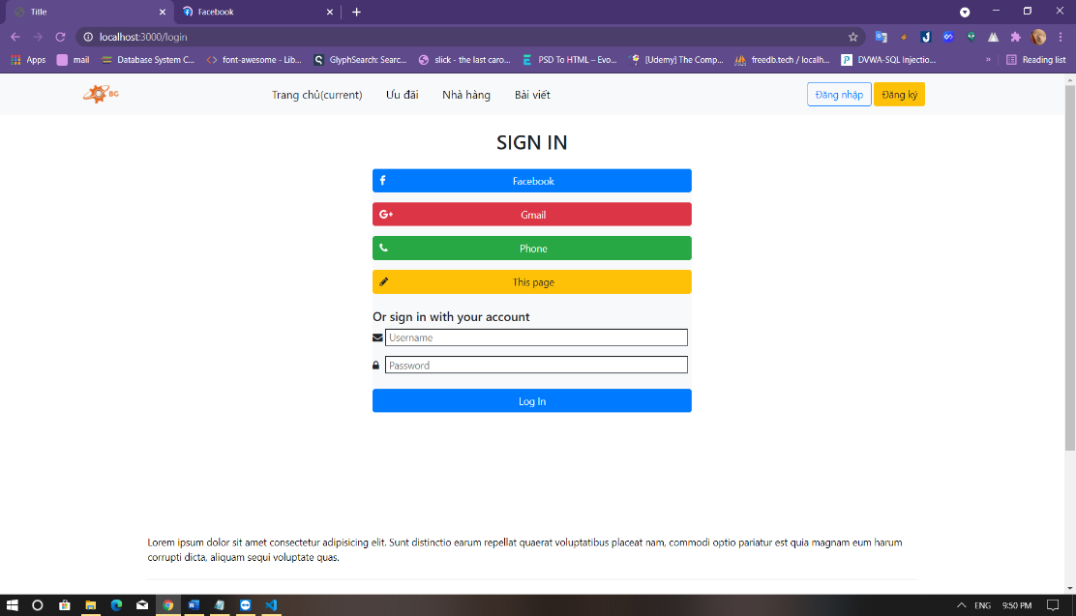

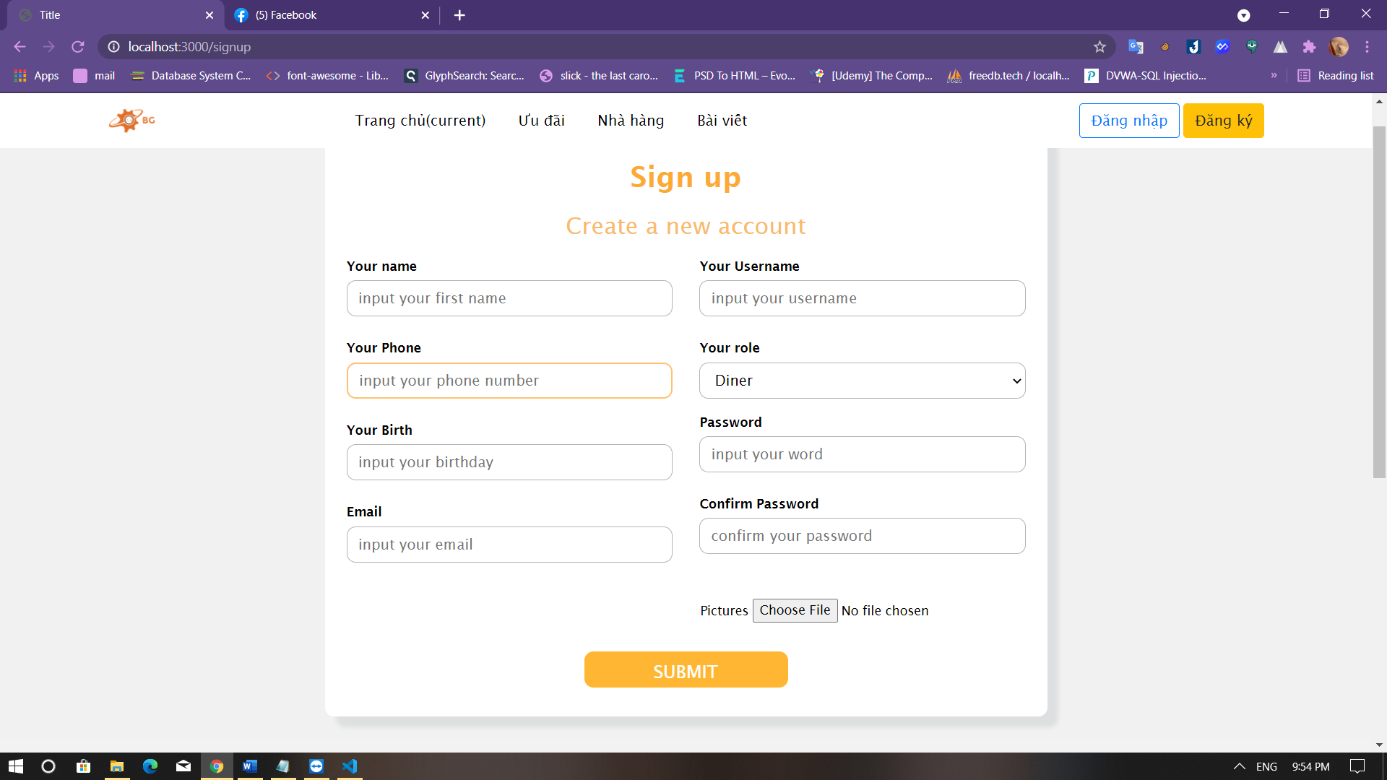

## User interface

### Main interface

### Restaurant list

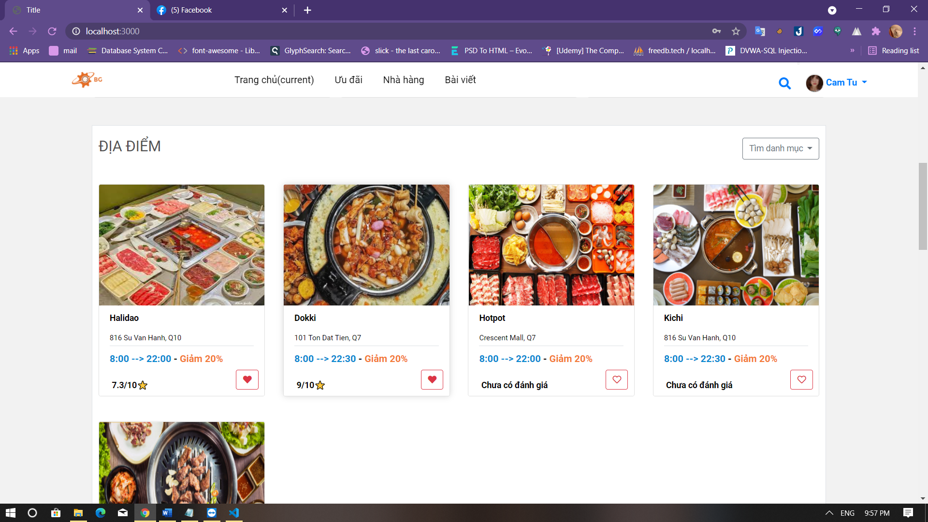

### Add to list favorite

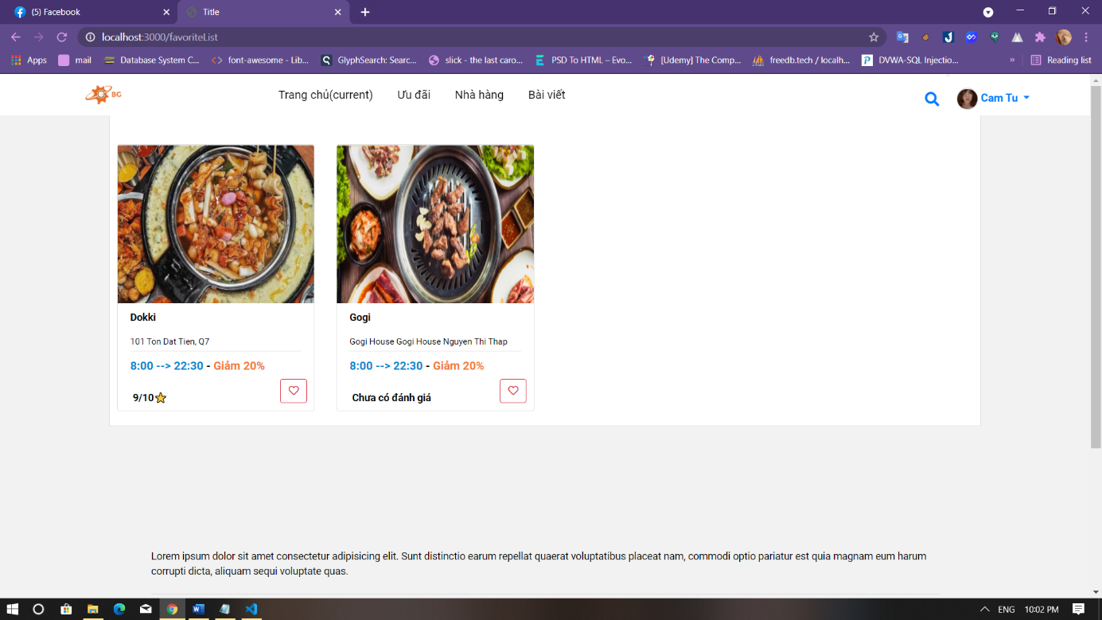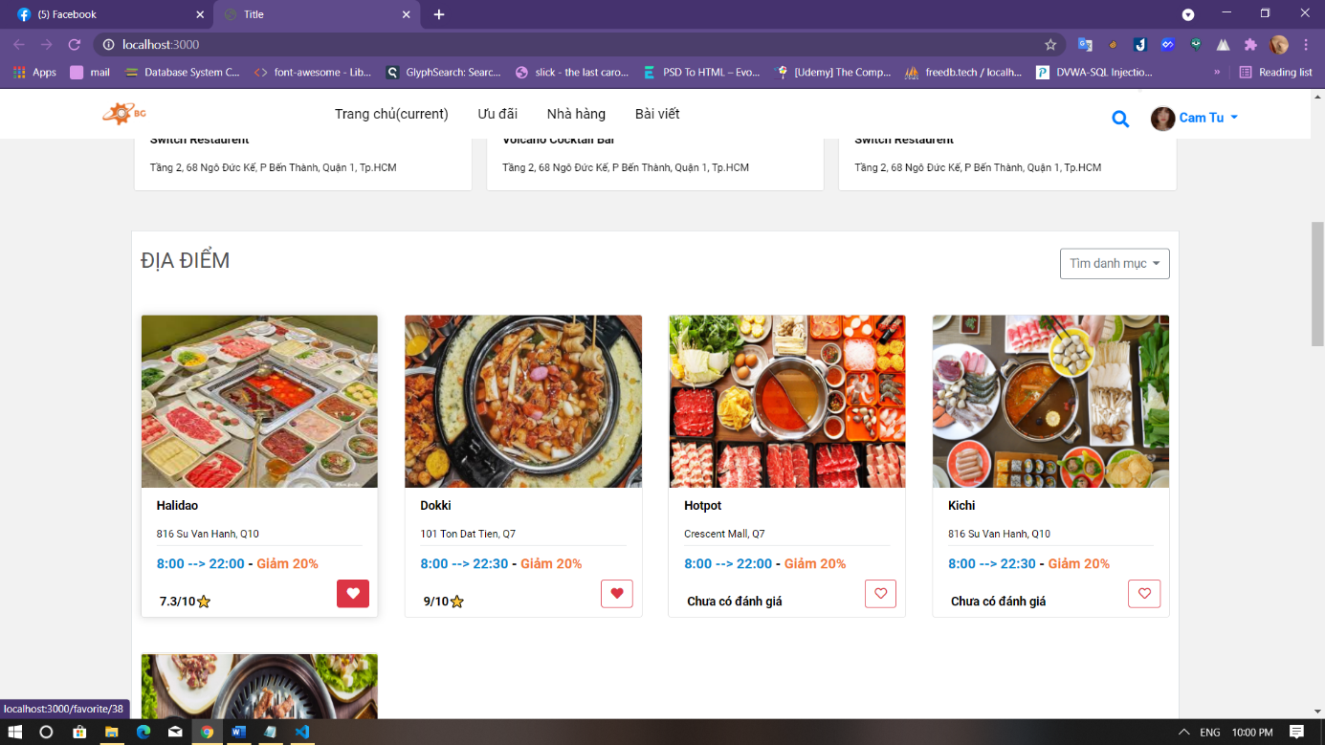Then choose list favourite

### Information helpful

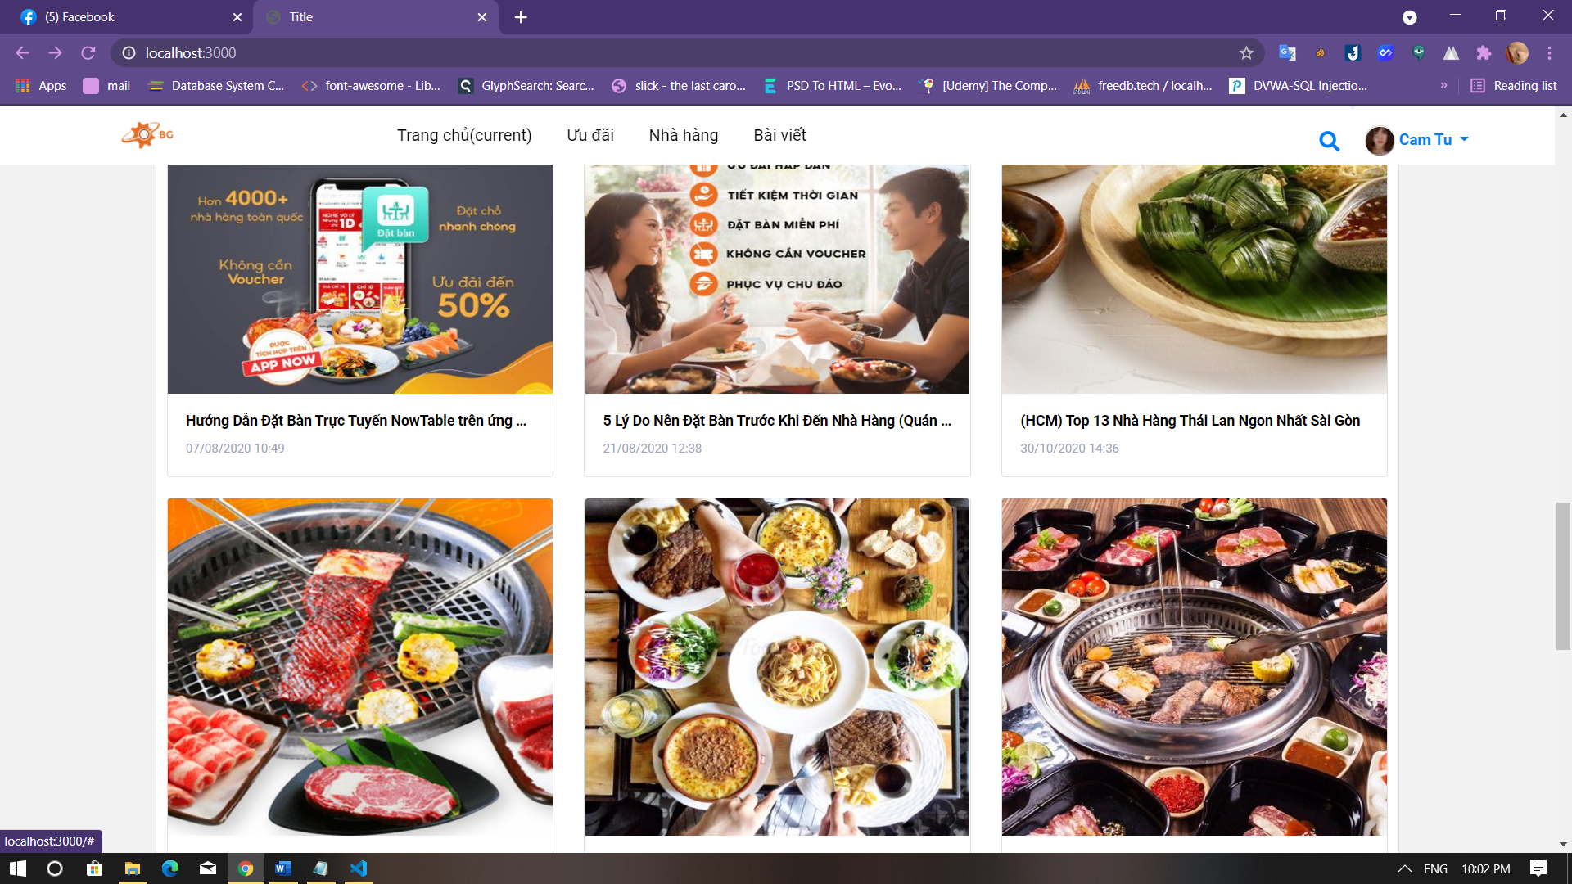

### Booking table

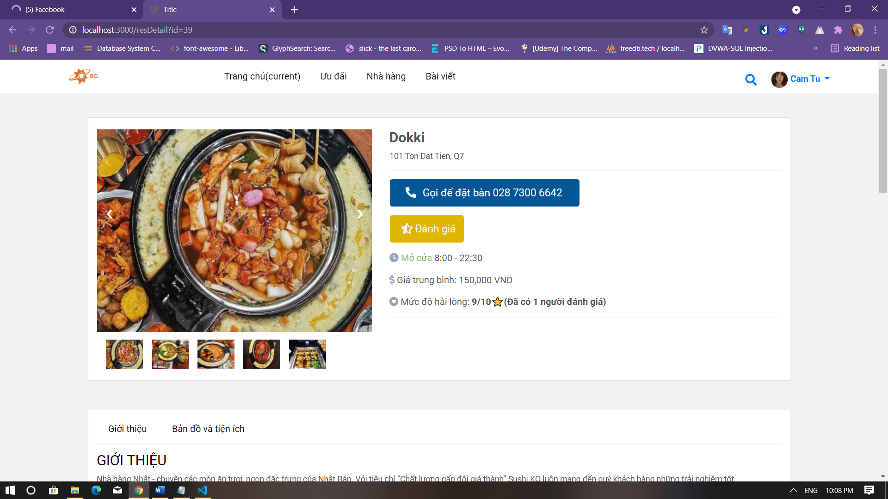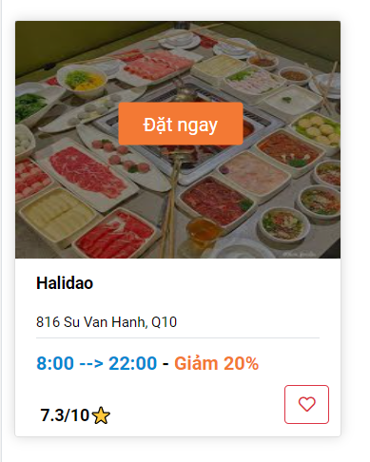

### Review

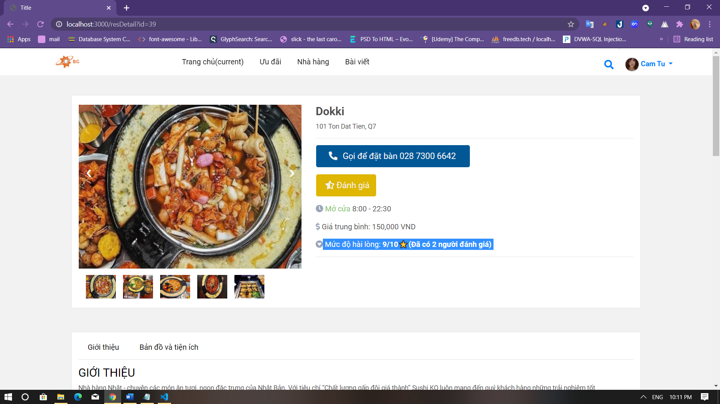

## Manager interface

Same as interface when logging in diner without:

### Admin page

### List restaurant

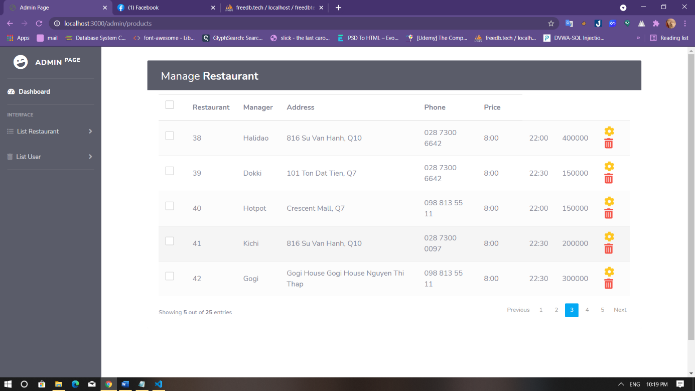

### List user